

STRATHMORE UNIVERSITY

FACULTY OF INFORMATION TECHNOLOGY

BACHELOR OF INFORMATICS AND COMPUTER SCIENCE

LEARNER’S FORUM

AMANI NEWTON : 101292
RAJ GAMI : 100226

Final system documentation for informatics project, submitted to the Faculty of Information Technology in partial fulfilment of the requirements of the requirements for the award of a degree in Informatics and Computer Science.

Date of Submission: 2nd November 2018

Declaration
We declare that this project has not been submitted in Strathmore University or any other University for the award of a degree in Informatics and Computer Science or any other degree.

Student Signature:

Sign: _______________ Date: _______________

Student Signature:

Sign: _______________ Date: _______________

Supervisor’s Approval:

Sign: _______________ Date: _______________

Abstract
Education being a major contributor towards the growth of a nation, there has to be measures towards ensuring every individual gets access to it. Education plays a major role in eradicating poverty and building a countries economy. In our country Kenya, the government has implemented measures to assist its citizens attain education. However, these are accompanied with new challenges that need to be addressed especially in this age of technological advancement.
Our country’s education sector has experienced some problems that has slowed down progress. They include inadequate learning materials and equipment for learners, e-learning resources being hard to access
In order to counter the slow progress and lack inadequate resources, there was need to have an automated system that can be used to access learning materials. The system can be updated from a central point from time to time in order to make sure all learning institutions have the required content for the curricular.
The design, test and implementation of the system was done procedurally. The user interfaces and functionalities contained in them will be implemented using mark up and scripting languages, HTML and JavaScript. Styling will be done using CSS. The database for this project will be done with MySQL.

Table of Contents
Declaration ii
Abstract iii
Table of Contents iv
List of Figures vi
1. Chapter 1 Introduction 1
1.1. Background 1
1.2. Problem statement 3
1.3. Aim 3
1.3.1. Specific Objectives 3
1.3.2. Research Questions 4
1.4. Justification 4
1.5. Scope and Limitations 4
2. Chapter 2 Literature Review 2
2.1. Introduction 2
2.2. Challenges Encountered by Learners when Accessing Tutoring Services. 2
2.3. Existing E-learning Resources 3
2.3.1. Khan Academy 3
2.3.2. Coursera 3
2.3.3. Newsela 4
2.4. Problems in existing E-learning Systems 5
3. Chapter 3: Methodology 6
3.1. Introduction 6
3.2. System Development Methodology 6
3.3. Deliverables 8
3.3.1. Module A 8
3.3.2. Module B 8
3.4. System Development Tools and Techniques 8
3.4.1. Hypertext Mark-up Language 8
3.4.2. Scripting 8
3.4.3. MySQL 8
3.4.4. PHP 8
4. Chapter 4: System Analysis and Design 9
4.1. Introduction 9
4.2. System Requirements Analysis 9
4.2.1. Functional Requirements 9
4.2.2. Non-Functional Requirements 9
4.2.3. System Narrative 10
4.3. Design Diagram 10
4.3.1. Use Case Diagram 10
4.3.2. Entity Relationship Diagram 11
4.3.3. Data Flow Diagram 12
4.3.4. Database Schema 13
5. Chapter 5: System Implementation and Testing 14
5.1. Introduction 14
5.2. Administrators Module 14
5.3. Tutors Module 15
5.4. Students Module 16
5.5. Forum 17
6. Chapter 6: Conclusion, Recommendations and Future Works 19
6.1. Introduction 19
6.2. Conclusions (based on objectives) 19
6.3. Recommendations 19
6.4. Future Works 19
References 20

List of Figures
Figure 2-1 Khan Academy Website, Source: https://www.khanacademy.org 3
Figure 2-2 Coursera Website, Source : coursera.org/ 4
Figure 2-3 Newsela Website, Source: https://newsela.com 5
Figure 3-1 System Development Methodology – The RAD Model 7
Figure 4-1 Use Case Diagram 12
Figure 4-2 Entity Relationship Diagram 12
Figure 4-3 Data Flow Diagram 13
Figure 4-4 Database Schema 14
Figure 5-1 Administrator module course creation 15
Figure 5-2 Administrator Module Management of Student Records 16
Figure 5-3 Administrator Module Department Creation 16
Figure 5-4 Tutors Module Student Registration 17
Figure 5-5 Student Module Profile Management 18

Chapter 1 Introduction

Background
Education was without a doubt, a key pillar in the growth of a nation. Many nations around the world have devised techniques that ensure all their citizens have access to basic education. There are benefits that countries with high literacy levels among their citizens enjoy. They are evident in the economic growth and stability of these nations, crisis and disaster management to mention a few.
In our country Kenya, the government has done its best to ensure the citizens have acquired at least primary education. The introduction of free primary education in the year 2003 by the former president HON. Mwai Kibaki, a step towards achieving this goal. This move was aimed at reducing and possible eradicate poverty, boost the economic growth of the country and increase the collective income of the country. Thereafter, there have been other major developments in the education sector.
According to some research firms, it was estimated that as of the year 2012, the literacy level among the Kenyan youth and the younger school-going generation was at an approximate of 82%, which reduced to 72% in the year 2015, (“Statistics | Kenya | UNICEF,” n.d.). This was evidence of the slow but sure progress that came as a result of the free primary education policy since 2003. This was boosted further when secondary education was included in 2008, and the efforts the effort made to provide learning materials to learners in public schools, all funds from the Kenyan government and other organisations, (“Kenya Education > Secondary education Facts & Stats,” n.d.).
With the number of learners increasing with time, the need for more advanced and effective methods of teaching was necessary. Automation of the manual modes of teaching and acquiring knowledge was growing rapidly. This therefore needs to be regulated in order to ensure that the information available was that which was required. With these changes taking place, the government has taken further steps in offering the optimum in education, the most trending topic being the class one laptop project.
Schools have been encouraged to provide online learning materials because of the availability of the e-learning gadgets that make it much easier to access information. Tertiary education in the country was undoubtedly the most developed. The Colleges and Universities in the country are equipped with computers that are used for research and learning. Our primary and high schools need to find ways in which they can avail their learning content online.
Having a common and guided curriculum to follow, the automation of learning in primary and secondary schools can be made with effectiveness. This should aim at taking the advantage of technological growth in the country. Having automated systems will help in reducing the problems learners face. As the country aims to offer global standard education, they need to invest in it in order to compete favourably with other countries of the world.

Problem statement
With the growth of our country’s population and the need for more people to get education, there have been challenges that have come about. The advancement of technology with regards to the education sector has also forced the responsible stakeholders to embrace change.
Communication and sharing of learning materials and knowledge has become necessary in large scale as compared to previous times. Most of the learning systems are being automated and therefore platforms for sharing knowledge and learning materials was required.
The major problem was the ease to access information and learning materials by learners. Large parts of our country are not covered by network connectivity and therefore accessing online resources possess a great challenge
The curriculum keeps on changing from time to time and the time it takes to implement change manually was quite slow and cumbersome. Some of the schools in rural areas wait for long to get text books and learning materials supplied to the schools. This forces them to keep on using outdated curricula.
To acquire learning materials can sometimes be above the ability of most Kenyan citizens and this hinders the passing of knowledge between learners. Many learners, especially in primary and secondary are affected by this.

Aim
To develop a system that will enable learners to share credible information freely within their learning institutions and enable them to interact with their tutors.

Specific Objectives
- To investigate the challenges that learners face while accessing learning materials.
- To analyse the existing learning systems and identify its problems
- To develop test and implement a platform that will ease the automation of the learning process.

Research Questions
- What challenges do learners face while accessing learning materials?
- What are the problems that face the current systems learners use for study?
- How are learning applications and websites designed, tested and implemented to assist learners acquire academic content?

Justification
The reason for this project was to create a platform for learners and tutors to share information for learning purposes. The sharing of information online has become common and this has led to spread of confusing and at times false information to those using online sites.
Credible sources are required especially in maters dealing with education. The application was intended to provide information to students, by allowing them to communicate with their tutors and other students in a question and answer forum. This will function to reduce the chances of receiving general answers for questions asked by users.

Scope and Limitations
The system was to be implemented with the learners and tutors of a specific learning institution in mind. The system was to allow the users to register and log in only with the credentials that the learning institution
Time will be the main limitation for the project. Implementing all the modules to access all the courses or units offered in an institution will be time consuming. More time will be required to implement more complex functionalities.

Chapter 2 Literature Review

Introduction
This chapter discusses the challenges encountered by students while revising for their exam. It also highlights the existing revision application available. Finally, the chapter highlights the gaps in the existing systems.

Challenges Encountered by Learners when Accessing Tutoring Services.
Since the beginning of the 8.4.4 learning system, the country has witnessed problems like low transition of learners from one stage to another, and low literacy levels, even though they have improved but not to as targeted.
In this era of technology, the internet has come with its advantages. Most information and learning materials are found online. This however becomes a challenge to learners when searching for specific information. The internet was in most cases, giving general views and answers to the questions asked. The researchers then have to spend a lot of time, which would however be used to learn further, looking for small items. Some information was often irrelevant and does not abide by the requirements of a curriculum.
Most online study materials are usually on sale. Given that not everyone may be able to afford funds to buy every single document, this becomes a challenge to them, denying an opportunity to learn. Pricing of some information may also be too expensive compared to the type of information offered.
Different countries have a different mode in which they use to teach. There are different education modes such as the 8.4.4 used in Kenya, the British system, American system and Arabic system to mention a few. They all have different modes in which they deliver their academic content to their learners and this may hinder research especially in primary and secondary levels.

Existing E-learning Resources

Khan Academy
The Khan Academy website was designed to provide knowledge to learners online. It involves a registration process. New users must sign up and select a course they wish. The application also provides some information on courses to take. There was a question and answer forum where people post and answer questions. It was diverse since it provides an option to select the level of education one has, from kindergarten to tertiary studies and other options if needed.
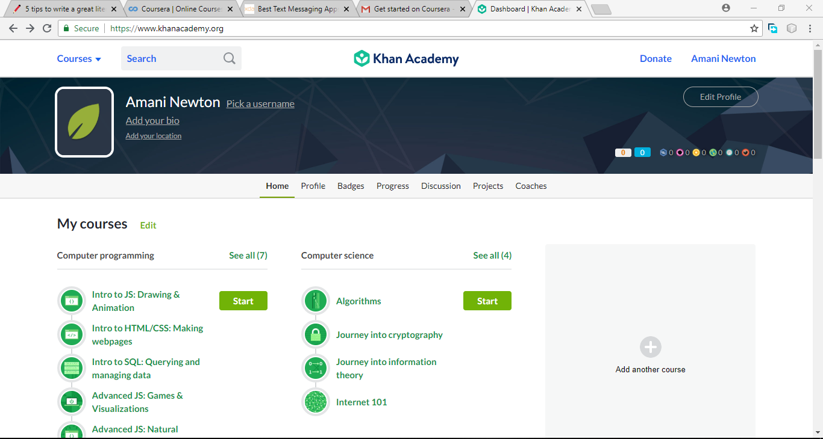
Figure 2-1 Khan Academy Website, Source: https://www.khanacademy.org
Learners can also monitor their progress and create projects to be shared to all.

Coursera
In this web application, new users are required to create an account as the registration process. The users then can pick a primary and secondary language that they will need for learning. A list of the courses available was provided for the learners to select any. A learner can make a search to get the specific course they want to learn about. Users who have enrolled for a course will study online and certification will be awarded at a fee.

Figure 2-2 Coursera Website, Source : coursera.org/

Newsela
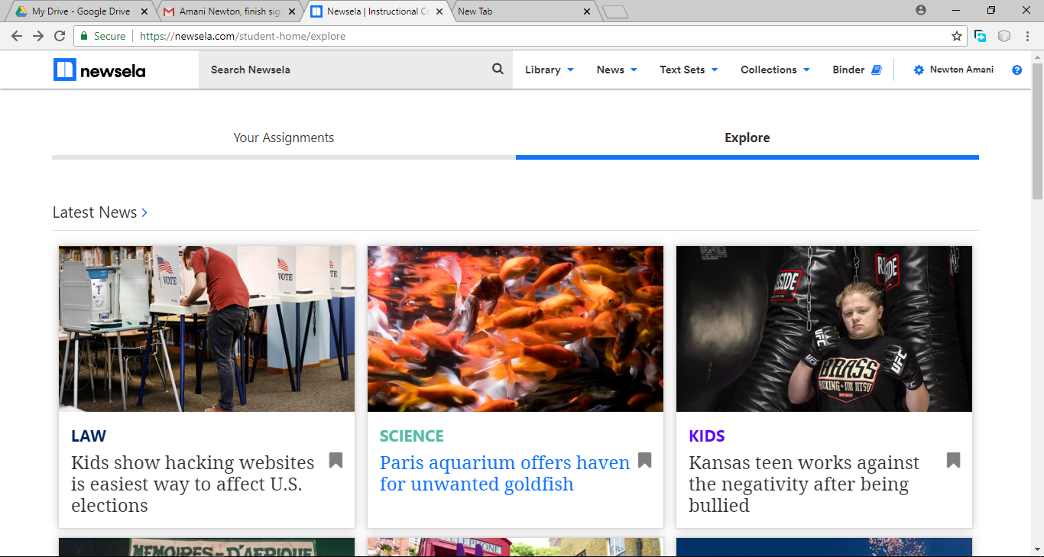
The web application provides registration for new users. They can be educators or learners. An educator can make a class in which their students can enrol through a link. Learners can also enrol separately and then select a topic of study.
Figure 2-3 Newsela Website, Source: https://newsela.com

Problems in existing E-learning Systems
The information available in these sites may look similar but they may not match the skills or level of knowledge that the users have therefore making it hard for them to interpret.
Most of these sites are made by institutions in countries abroad. Some of these sites focus on the curriculum they offer in their country of origin and they may not favour learners of a different country.
Some of the answers provided in various websites are meant to target a general scope or view. They may be of little help to students who seek information specific to a topic. They offer courses to study which may be bulky to researchers.
Some of the sites offer tutorial videos but in cases where the learner does not understand clearly, it may take a long time for the tutor to respond to their questions. Other platforms do not offer any tutor-learner interactivity.
Most learning institutions have a way in which they have customised their course outlines or syllabuses. The mode of teaching will therefore slightly vary between different institutions. The learners may therefore access information from other sites that does not conform to what they require. (Zhang & Nunamaker, 2003)

Chapter 3: Methodology

Introduction
This chapter involves discussing the system development methodology and the numerous stages involved in it. It also exhibits the system analysis and design aspect of the system. Finally, the chapter informs about the system development tools and techniques.

System Development Methodology
This refers to the software development breakdown into discrete phases with the objective of successful planning and management of the entire process. Among the various software development life cycle models, this project shall use the Rapid Application Development (RAD) Model. (Beynon-Davies, Carne, Mackay, & Tudhope, 1999)

Figure 3-1 System Development Methodology – The RAD Model
Business Modelling was a stage that takes information collected from various related sources. The analysis obtains all the information from the organization which was relevant to the project. This information was converted into a useful description of proper usage of the information after required processing.
Data Modelling was a stage that involves complete analysis of information collected in business modelling stage. Using the analysis, the information was divided into various groups that can be useful to the organization. Each division of the information was carefully studied and provided with an accurate description. As discussed in business modelling, these divisions and their importance was also established.
Process Modelling was the phase during which various divisions of information are combined to obtain the necessary usable information. During this phase, changes and optimizations to the data for further definition. Additional descriptions for adding, removing or altering data objects are also generated during this stage.
Application Generation was the phase when all the collected information was coded, and several progressive versions of the product are created. This product was created in several modules which will be tested in the next stage.
Testing and Turnover was the final stage of the RAD Model that allows for a shorter time in the complete testing of the prototypes created. Every module was tested separately so that the components can easily be identified and switched in order to create an effective final product. During this stage, most components of the module are already studied, so major challenges with the prototypes are not likely to occur.

Deliverables

Tutor’s Module
The tutor will be able to register as a user of the system, they can log in to the system, they can answer the questions posted in the forum and can log out at will. They will also be able to share educational documents in the system.

Student’s Module
They can register as users of the system. They can be able to log in afterwards. The learners can post and answer questions in the forum, share documents and thereafter log out at will.

Administrator’s Module
This was the super user of the system. This administrator shall be able to add tutors and student as an alternative to the self-registration functionality that the system contains. The administrator was able to add/ remove units, tutors and students as an override functionality. The administrator was also able to view logs of logins by various other users.

System Development Tools and Techniques

Hypertext Mark-up Language
This will be used to design the structure of the user interface. HTML will be used together with Cascading Style Sheet to style the user interface.

Scripting
JavaScript will be the main scripting language. It will be used to implement and improve the functionality of the system.

MySQL
This will be used for creating the database for the system. It will contain all the user details and the posts made in the forum

PHP
This programming language will be used to manage data from and to the database. It shall be used to create queries to insert, update, delete or select data from the database and display it to users or obtain user input and store it into the database.

Chapter 4: System Analysis and Design

Introduction
System analysis was the process of collecting and interpreting facts, identifying the problems, and decomposition of a system into its components. It was conducted for studying a system or its parts to identify its objectives. System design was the process of planning a new business system or replacing an existing system by defining its components or modules to satisfy the specific requirements

System Requirements Analysis
The purpose of System Requirements Analysis was to obtain a thorough and detailed understanding of how the target users of the system would interact with the system and develop the system considering the findings. It focused on the quality of the systems functionality, to give the users

Functional Requirements
The system was able to accept user registration and selection of courses of interest. They were afterwards able to access the discussion forum. In the forum the system was able to allow users to create questions, each of them being under a unit that the users had registered to. The system allowed users to give response to questions posted by other people involved in the forum and view answers.
The system administrator was able add and remove users from the system.
Data must be entered before a request can be approved.

Non-Functional Requirements
The web application was easy to use. It has been made with simple designs using the bootstrap framework for an interactive user interface. The labeling and location of buttons, text boxes and other items of the application were done and designed for a user-friendly experience
The web application offers security of user credentials. The hashing of passwords using message digest algorithm was implemented to secure user data. There was also a verification pin required to register for a course. This ensured that there was no form of unauthorized access to the system. The system had limits to the number of users accessing the courses available. This was aimed at reducing traffic in the forums.

System Narrative
The application allowed new users to register into the system. This was be done using credentials specified by the system owners. Registration was limited to only those people who belong to an institution where the web application was deployed. Upon registration, the users were able to select a course and specific units to with regard to their course. All this information was saved in the database. Registered users were able to log in any time and use the platform.
The administrator was the supper user of the system. The administrator can create accounts for the tutors and the students in the case where the student’s self-registration fails. The tutors however must be registered by the administrator. Sessions, departments and courses for the system are registered by the administrator. Additionally, the administrator can also remove users from the system and reset passwords if necessary.
In the question and answer forum, learners were able to post questions to the whole community to answer. The questions are mainly intended for the tutors because of their professional experience but other can also give feedback. The comments will be available for people to read upon search of similar queries. The users were not only limited to posting comments but also be able to post documents and other informational content in the forum. Content posting was regulated by tutors, they allowed valid answers and reject invalid ones.
When a user was done with a unit, they can unroll from it and select others which they may be involved in. they still used the same account they created initially. The users were also able to log out at will and their sessions terminated.

Design Diagram

Use Case Diagram
The use case diagram shows the system’s behaviour together with the key actors for a specific scenario. (Kendall & Kendall, 2011) A formal model of use cases was proposed and its construction for typical relationships between use cases was described.
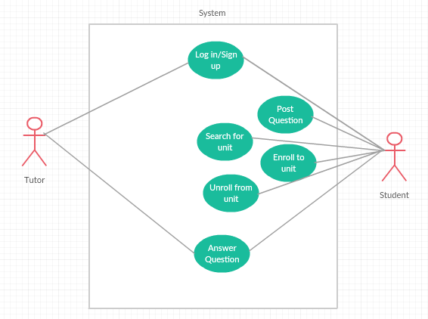
Figure 4-1 Use Case Diagram

Entity Relationship Diagram
An entity relationship diagram (ERD), or entity relationship model, was a graphical representation of an information system that depicts the relationships among people, objects, places, concepts or events within that system. An ERD was a data modelling technique that can help define business processes and be used as the foundation for a relational database. (Kendall & Kendall, 2011)
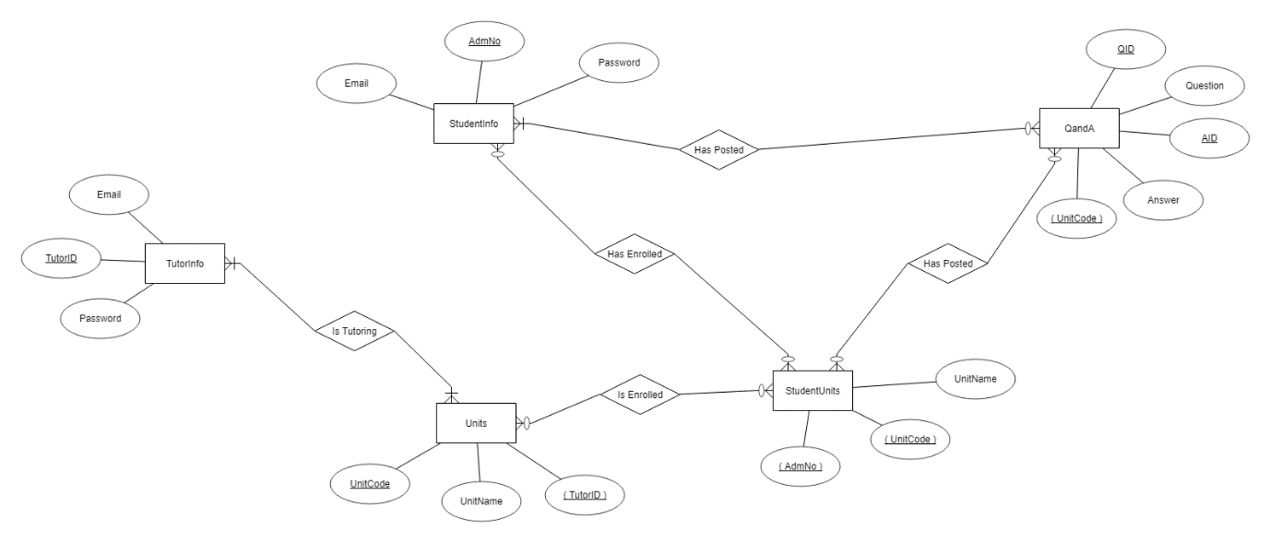
Figure 4-2 Entity Relationship Diagram

Data Flow Diagram
A data flow diagram (DFD) illustrates how data was processed by a system in terms of inputs and outputs. As its name indicates its focus was on the flow of information, where data comes from, where it goes and how it gets stored.
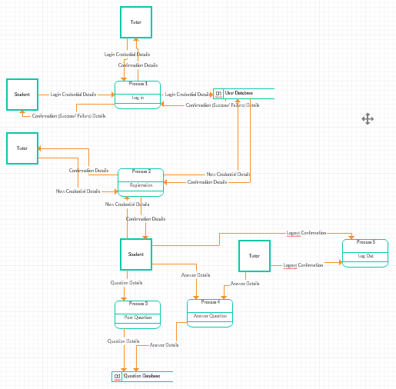
Figure 4-3 Data Flow Diagram

Database Schema
It was a structure that represents the logical view of the entire database. It defines how the data was organized and how the relations among them are associated. It defines all the constraints that are to be applied on the data.
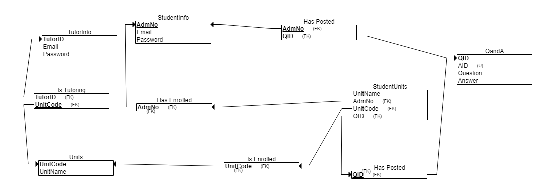
Figure 4-4 Database Schema

Chapter 5: System Implementation and Testing

Introduction
This chapter illustrates the system testing and implementation phase. It involved use of test data, input to the system and the results collected. Any corrections and modifications to the system were done to suit the systems functions.

Administrators Module
The module allowed the administrator to create sessions, courses, departments, register tutors and students and manage their registration records. On behalf of the other users, the administrator was able to edit their details when need arose or if they failed system failed to allow them to do so.
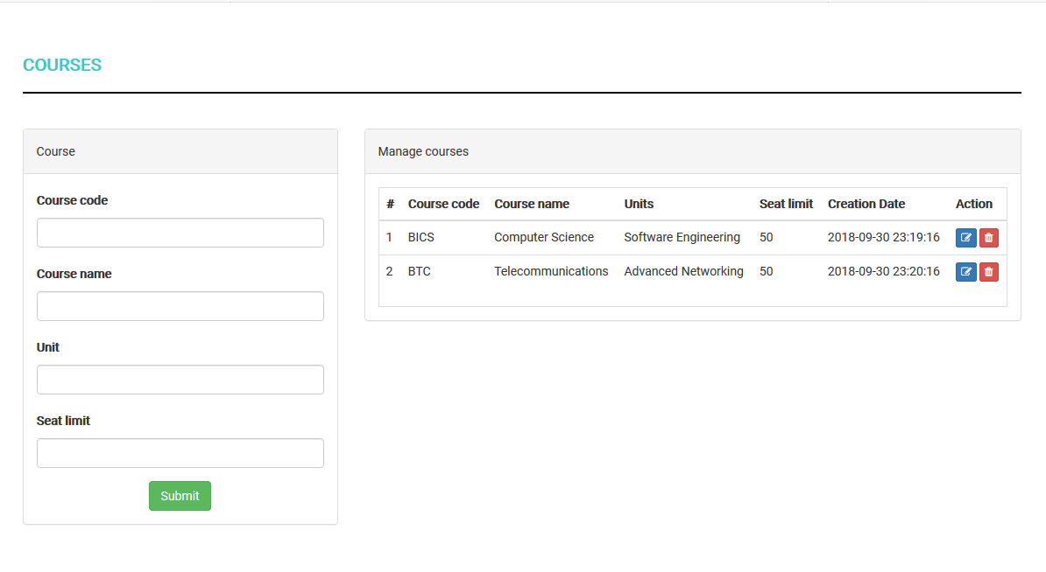
Figure 5-1 Administrator module course creation
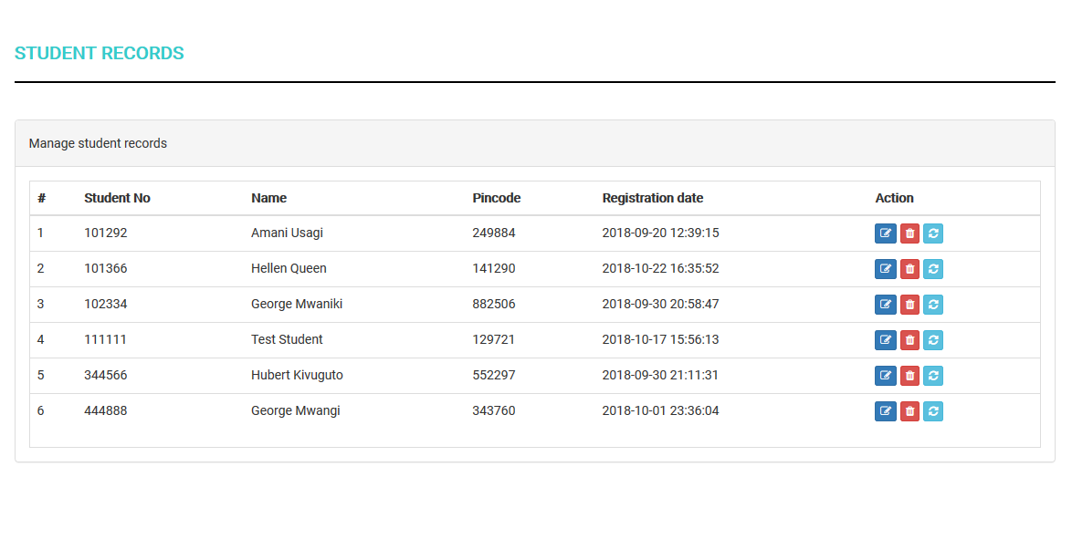
Figure 5-2 Administrator Module Management of Student Records
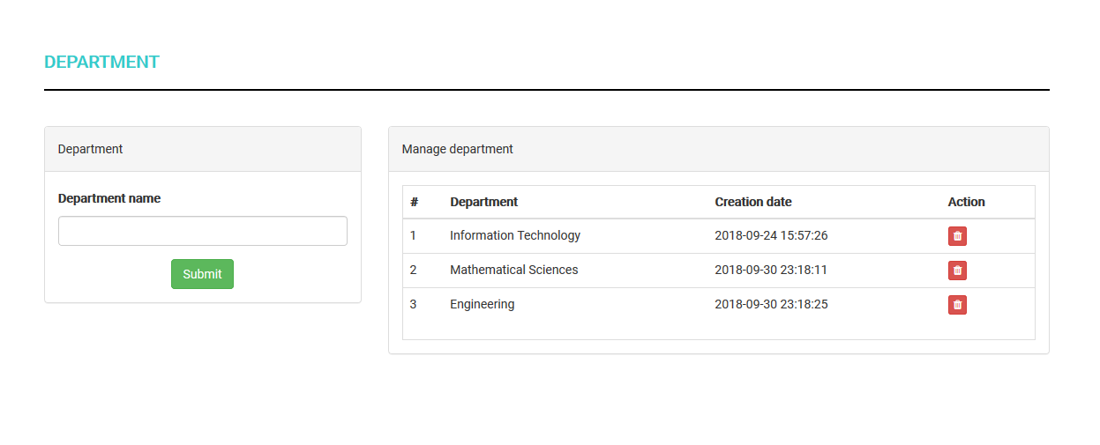
Figure 5-3 Administrator Module Department Creation

Tutors Module
The module enabled the tutors to sign into the system as users. They were also able to register for units they are qualified for. This was to enable them to access the learning forum to interact with the students. They were able to accept and reject answers to questions posted by the student. The tutors had some administrative abilities. They were able to register students into the system when need arose.
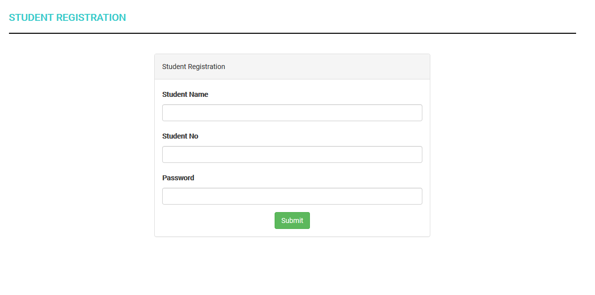
Figure 5-4 Tutors Module Student Registration

Students Module
The module enabled the learners to register as users to the system. They used credentials as specified by the system owners. The students were then able to enroll in units they wished to participate in. They were provided a security code that they needed to submit for verification before they could access course registration. After course registration, the forum was then available for them to post and answer questions.
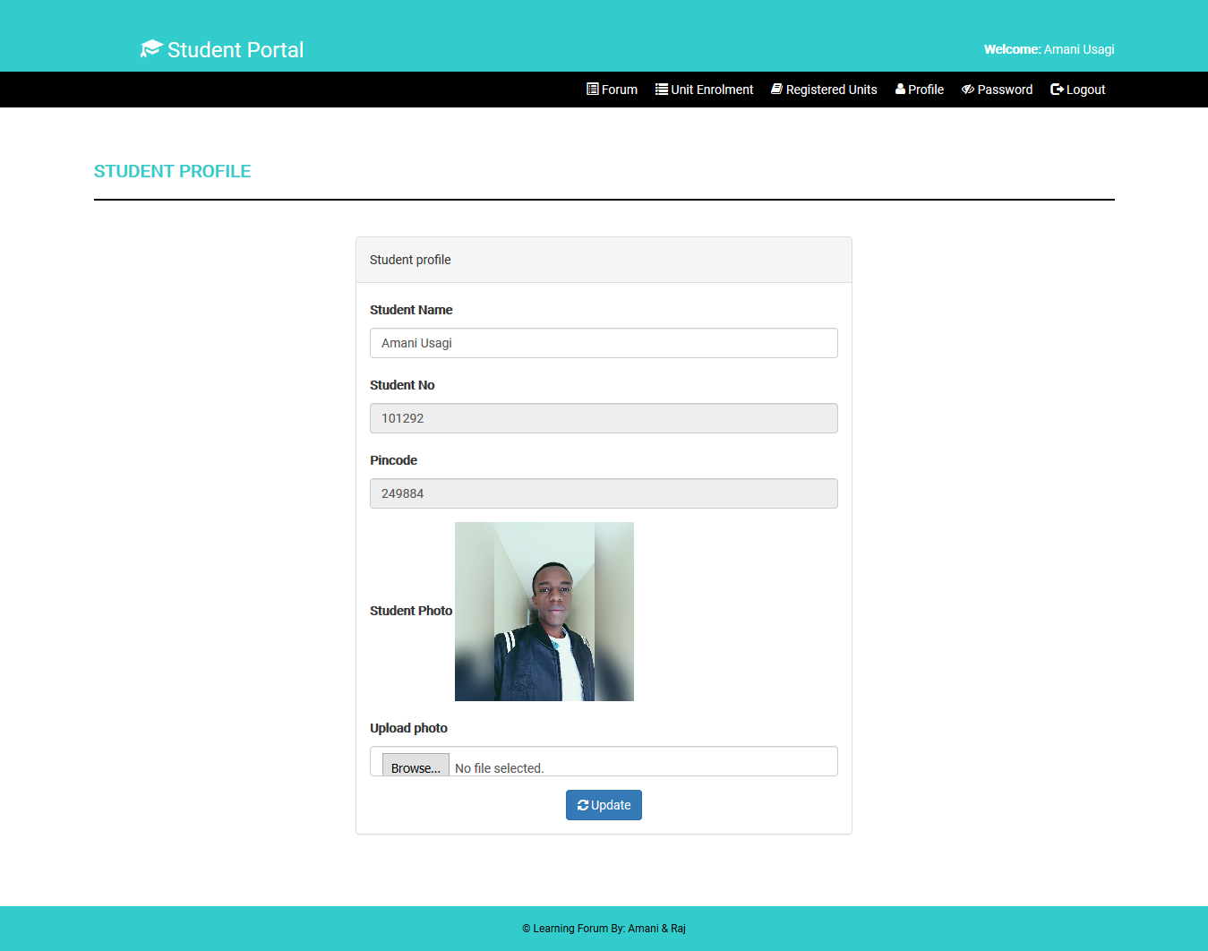
Figure 5-5 Student Module Profile Management

Forum
The forum was a platform mainly accessed by the tutors and the students. Here the students were able to post questions on various topics provided on the platform. They also had the privilege of responding to queries by other students. This was aimed at creating a community where exchange of information takes place.
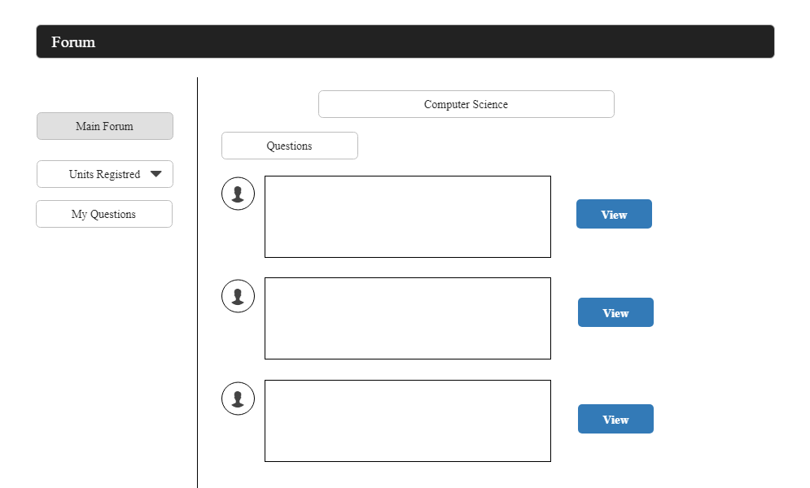
Figure 5. 6 Forum questions posted

Chapter 6: Conclusion, Recommendations and Future Works

Introduction
The research and development of the learning forum was to make a better, faster and efficient way for students to get learning materials and information more quickly and even further, interact with their tutors in a platform designed specifically for this purpose. The issues of delayed or no response, lack of funds to purchase learning materials, and time wasting in reading documents with a general scope of topics were addressed.

Conclusions (based on objectives)
The challenges faced by learners while acquiring information and knowledge for studies include lack on funds to purchase learning materials,

Recommendations

Future Works
For a more efficient and secure system, there was need for implementation of a more secure way of registration. The system will have to have a reference list of acceptable student and tutor information such as email and registration numbers to prevent malicious parties form accessing the system information.

References
Kendall, E. K., & Kendall, E. J. (2011). Systems Analysis and Design.
Kremer M, &. H. (2009, June 8). Literature: National Center for Biotechnology Information. Retrieved from National Center for Biotechnology Information: https://www.ncbi.nlm.nih.gov/pmc/articles/PMC3740762/
Kremer, M. (2009, June 8). Improving Education in the Developing World. What Have We Learned from Randomized Evaluations?
Beynon-Davies, P., Carne, C., Mackay, H., & Tudhope, D. (1999). Rapid application development (RAD): an empirical review. European Journal of Information Systems, 8(3), 211–223. https://doi.org/10.1057/palgrave.ejis.3000325
Kenya Education > Secondary education Facts & Stats. (n.d.). Retrieved October 28, 2018, from http://www.nationmaster.com/country-info/profiles/Kenya/Education/Secondary-education
Statistics | Kenya | UNICEF. (n.d.). Retrieved October 28, 2018, from https://www.unicef.org/infobycountry/kenya_statistics.html
Zhang, D., & Nunamaker, J. F. (2003). Powering E-Learning In the New Millennium: An Overview of E-Learning and Enabling Technology. Information Systems Frontiers, 5(2), 207–218. https://doi.org/10.1023/A:1022609809036

